Microsoft logo

Robotic Process Automation in a Day

Lab 2 – Create your first desktop flow

30 mins

April 2023

Applies to Power Automate Desktop v. 2.31.105.23101 ([more](https://learn.microsoft.com/en-us/power-platform/released-versions/power-automate-desktop))



This document is provided “as-is.” Information and views expressed in this document, including URL and other Internet Web site references, may change without notice. You bear the risk of  
using it. Some examples are fictitious and are for illustration only. No real association is intended  
or inferred. This document does not provide you with any legal rights to any intellectual property in any Microsoft product. You may copy and use this document for your internal reference purposes.

© 2021 Microsoft Corporation. All rights reserved.

## Lab Overview

You will complete the following tasks in this lab:

* Getting familiar with Power Automate Desktop flows
* Create a new desktop flow
* Record actions performed in the desktop-installed Contoso Invoicing application
* Perform a test run of the new desktop flow

## Prerequisites

This lab builds on the initial setup lab (Lab 1) – ensure all tasks are complete.

**Important Additional Prerequisite:** As you will be recording actions performed in your UI in this lab, **you will have the best experience if you view the lab instructions on a separate device or in a printout**. You can still complete the lab while using the instructions during UI action recording, but you will have to perform extra work to cut the recorded actions of viewing the instructions from the Desktop flow.

Also please check the known OS requirements and limitations here for Desktop flows <https://docs.microsoft.com/en-us/power-automate/ui-flows/setup>

# Getting Familiar with Power Automate Desktop

**Note:** Please complete Lab 1.3 Prerequisite - Install required software to install the latest version of Power Automate Desktop.

1. Launch Power Automate Desktop from your computer and sign into your account.

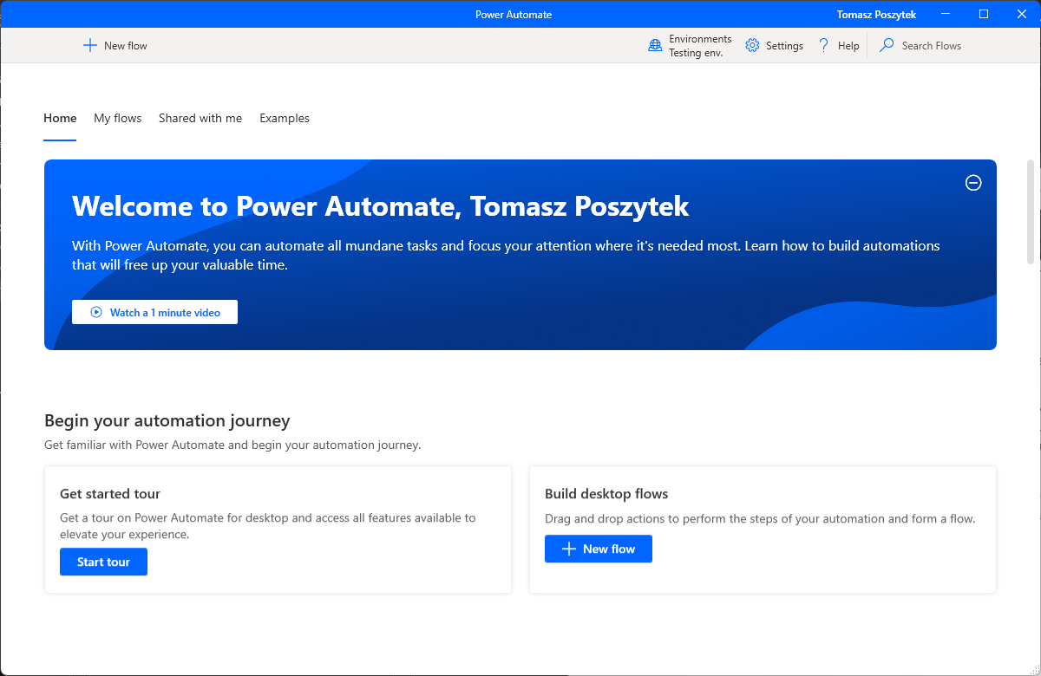

1. Click Environments dropdownto change your environment to the appropriate one. This is the same environment that was created as part of the prerequisites.

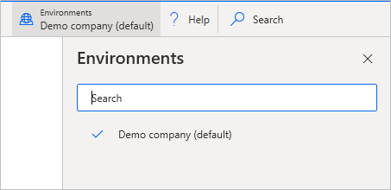

1. If you have any existing Power Automate Desktop flows. You can click … icon to Start, Edit, Rename and Delete them. If not, that is ok, as we will create one in the next step.

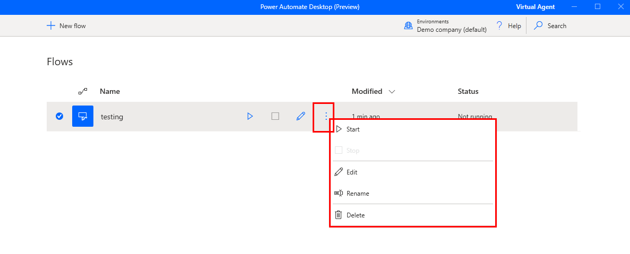

1. Now let’s click +New flow to create a new Power Automate Desktop flow.

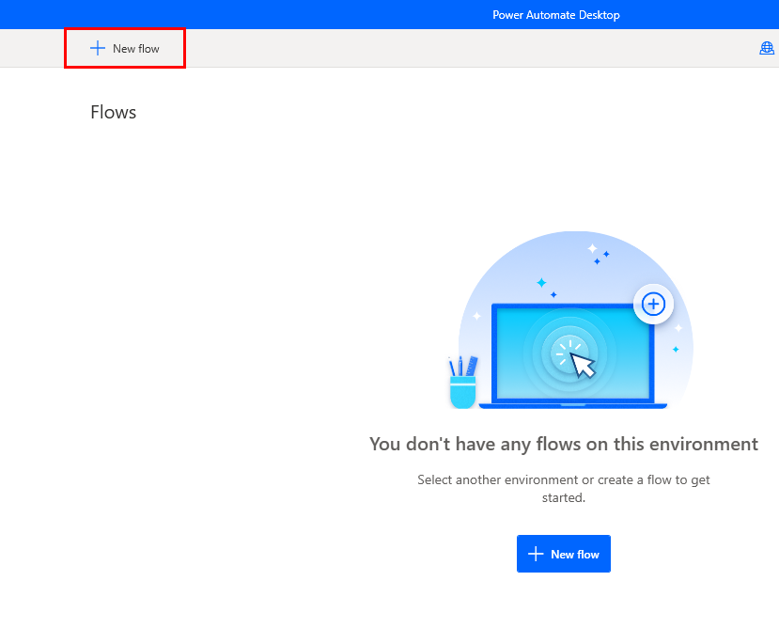

1. Name it testing and then click Create.

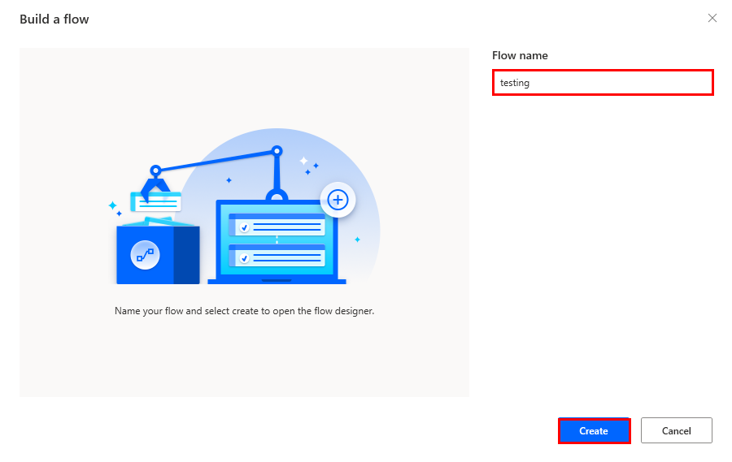

1. You might be seeing a tour box if this is the first time you log in. You can continue the tour or skip the tour.

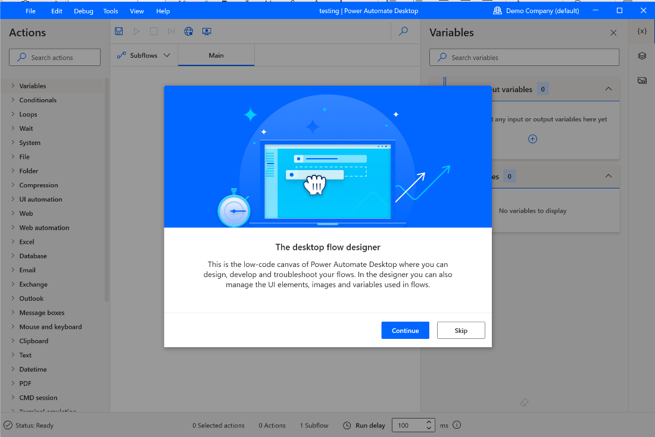

1. You will see the Power Automate Desktop designer which consists of the following toolbars and panes:
   1. The toolbar - Contains basic operations for use with actions (Save, Undo, Copy, Debug and Paste) as well as buttons to start the Desktop/Web Recorders, and control the process execution (Start/Pause/Stop).
   2. Subflows – Allows you to create subflows under your main flow.
   3. Actions pane - Contains all Power Automate Desktop Actions and includes a search bar that assists in finding specific actions by matching the action name to the text string.
   4. Workspace – Contains all the actions added to the process so far. Functions are separated into tabs.
   5. Input/output variables - Contains all the variables you created in the process.
   6. Flow variables - List of all variables used in the process.
   7. Navigation – Allows to switch between variables, UI elements and images.
   8. Console – Shows information about the process and its condition, e.g. all errors and warnings. Contains as well “Run delay” setting helpful in debugging.

1. Now you can save and close the window. Click Delete to delete the testing Power Automate Desktop flow.

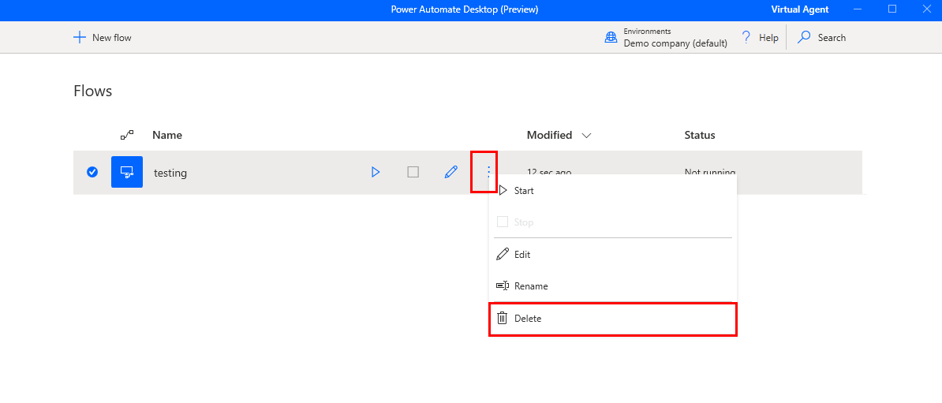

# Create your first Power Automate Desktop flow

**Note:** If you haven’t completed Lab 1.3 download and install the ContosoInvoicingSetup from the **lab data packages folder**. Pin the app icon to the task bar for quick launch. We will use this app for the recording.

You will need to click “More Information” and “Run it anyway” during installation of the Contoso app if Windows Defender prompts that the app is coming from untrusted source. This is normal and doesn’t expose any risk.

1. Open an Edge (chromium) or Chrome browser (using the test profile in 1.2 if needed) and navigate to <https://make.powerautomate.com/> then log in use the test account

**Note**: Please don’t use the flows tab from powerapps.com**.**

1. If this is the first time you log into this site, you will need to choose your country/region then click Get started button.

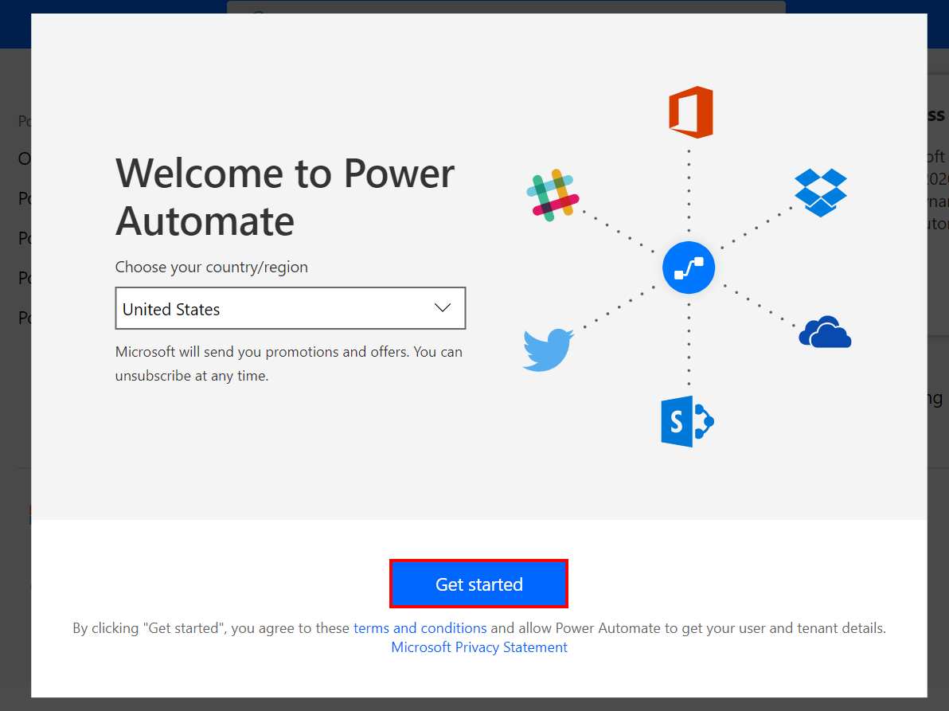

**Note**: Please make sure you have selected the correct environment (with database) to use for the labs (either use the one you created in lab 1.1, or what your instructor provided you with). You can switch between different environments by clicking on the Environments button on the title bar.

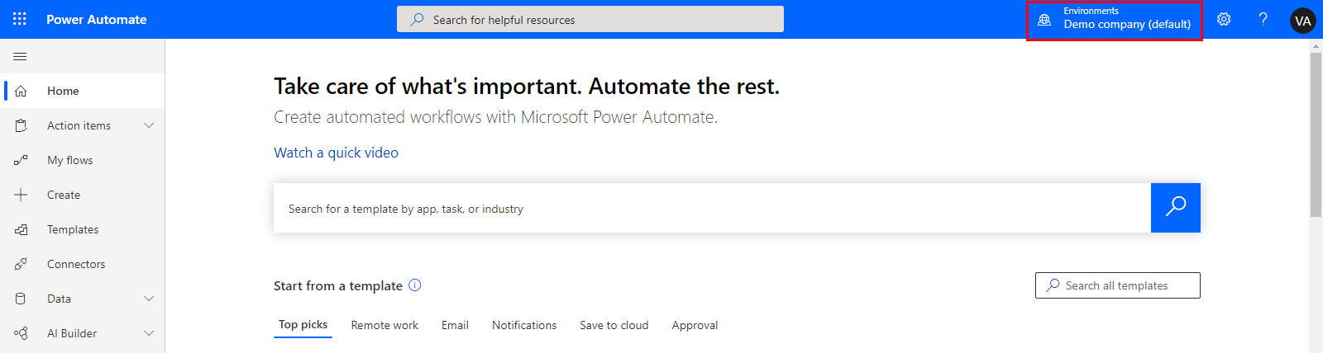

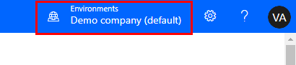

1. Click My flows on the left navigation menu

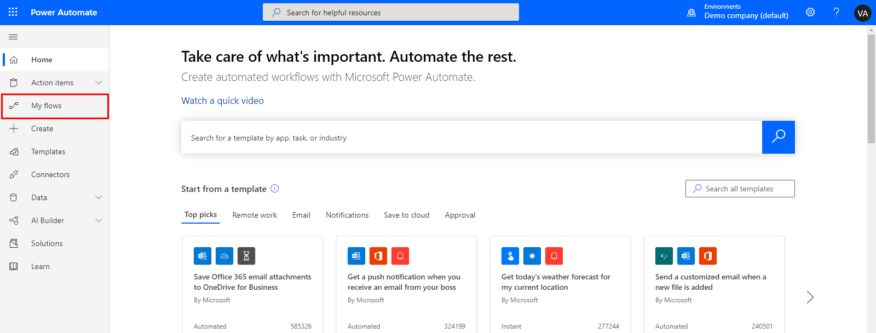

1. Select Desktop flows tab

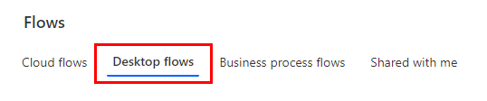

1. Click + New flow.

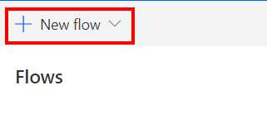

1. Select **Desktop flow**

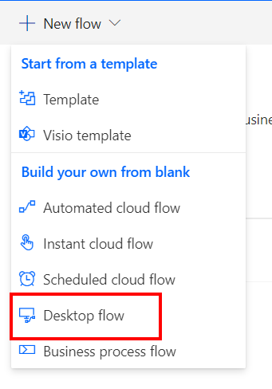

1. Name your flow as Enter an invoice, then click Launch app.

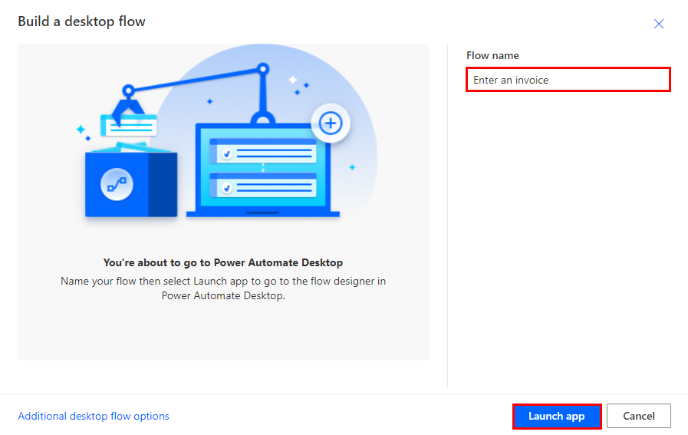

1. Check “Always allow” checkbox and click Open to open Power Automate Desktop.

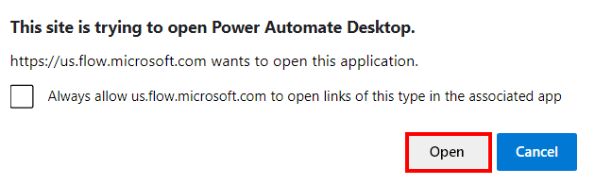

1. In the search bar, type “Run application" then drag the Run application from the left drop down list to the right.

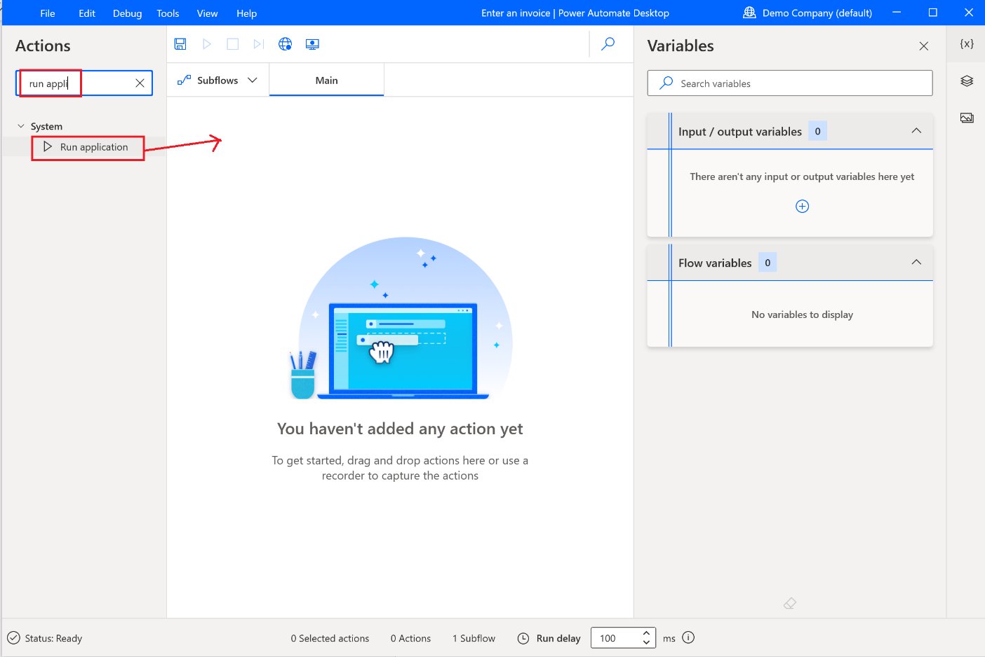

1. Enter the location path of Contoso Invoicing app under Application path. (This will open the Contoso Invoicing app when you are running your flow).

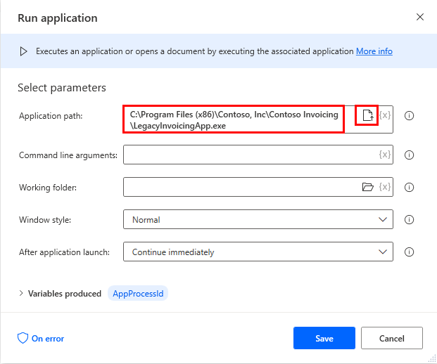

1. Click Save.

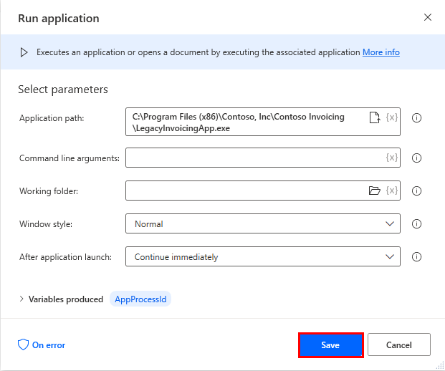

1. Open and minimize Contoso Invoicing app manually, then click Recorder.

**Note:** Ensure the Power Automate Desktop Process editor is maximized to ensure the Desktop recorder button is visible.

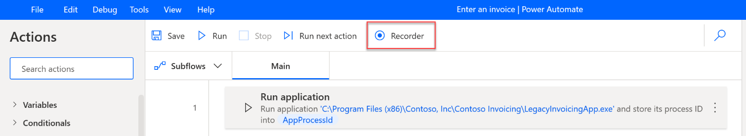

**Tip 1:** Now we are going to start recording. It is recommended you get familiar with steps below until the recording is done. This allows you to finish the recording in one shot without the need to go back and forth with this manually. If your first few recordings were not very good. Feel free to delete the recording after (using the … icon) and practice more until you have a good recording.

**Tip 2:** to help with the resilience of UI automation playbacks, it is recommended to minimize other apps from your desktop.

1. Make sure the Contoso Invoicing app is opened. Now click the Recordbutton.

1. In the Contoso Invoicing application, Click Invoices.

**Tip**: As your mouse hovers over controls in the app, you'll notice that a red outline highlights each control. Don’t record at very fast speed and always wait a bit between each mouse move and click, until you see the blue highlight rectangle around the control first, before you click to select the control. If the red highlight did not show up before you click, the action might not be recorded properly.

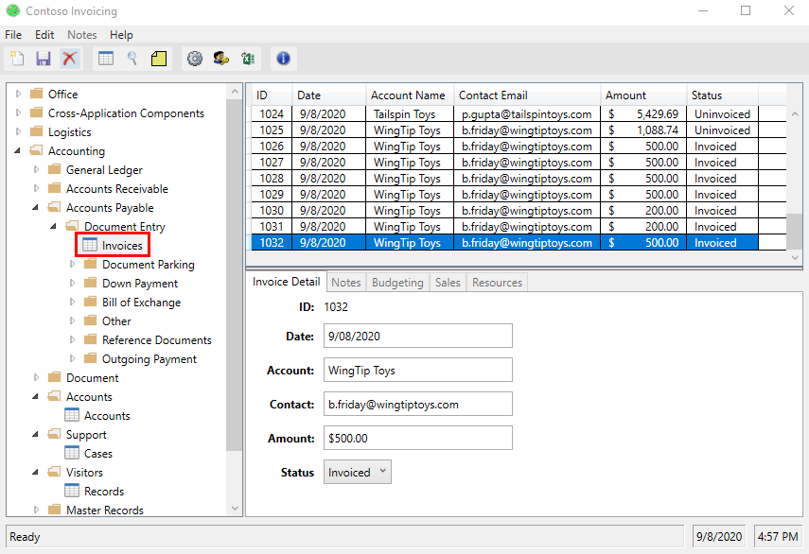

1. Create a new record by clicking New record icon on the left

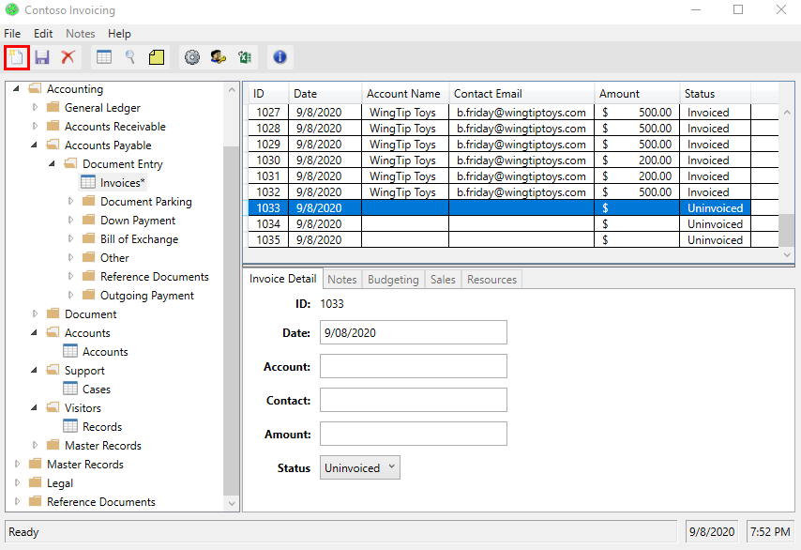

1. Use these values to complete the recording (Note you can also use any arbitrary values)

* Date: Current date
* Account: WingTip Toys
* Contact: b.friday@wingtiptoys.com
* Amount: $500
* Status: Invoiced

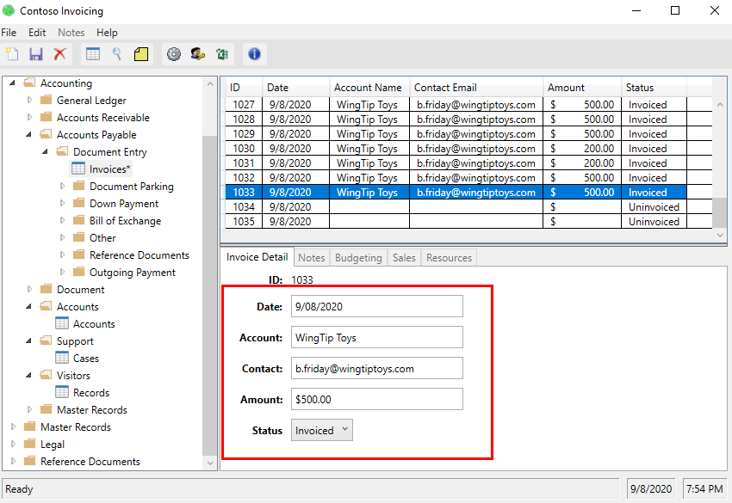

1. Click Save icon to keep your changes.

Ope :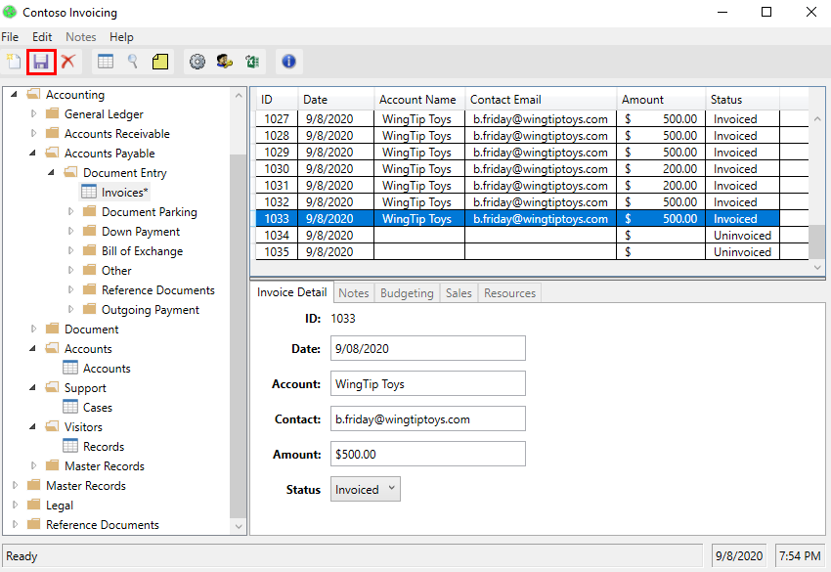

1. Click Done and close the Contoso Invoicing app.

**Note:** We did not record closing the app. This is for simplicity to view the result as the Contoso app will remain open after we test the Desktop flow. In a real-world use case, you can decide to record the closing action or not.

**Note 2:** By default, the Desktop flow will launch a new instance of the app every time when it runs. Even if you leave the app open, the next Desktop flow run will launch another new app window. You can also change this behavior to only attach to existing app instead of launching another new instance from the portal (details see following steps).

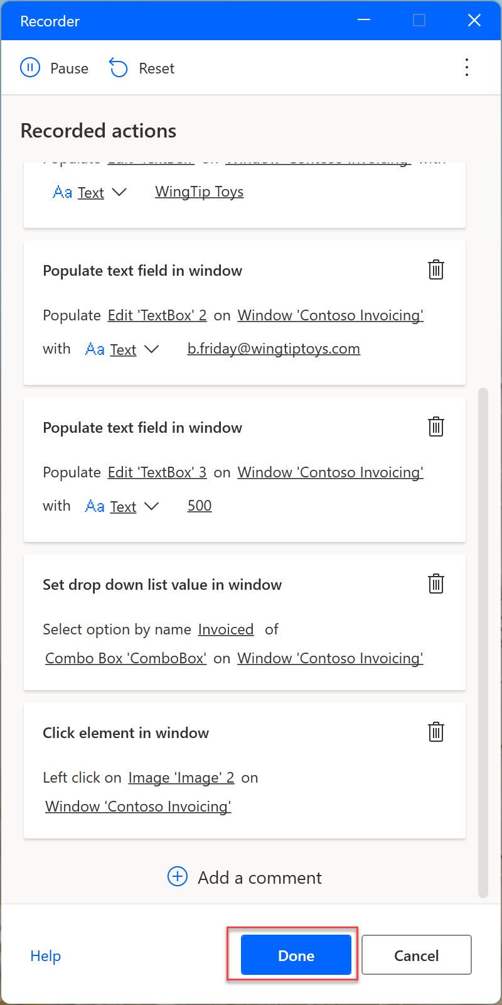

1. Within Power Automate Desktop, you can view the recorded script with the screenshots of each step by clicking the ellipsis (…) icon > Edit. You can also do some editing here.

**Tip 1:** Select the ellipsis (…) icon in each action’s header > Delete selection to remove any duplicate steps or the entire script.

1. You can click Run to test your flow.

**Note:** Don’t interact with your device during testing. You will see the recording played back successfully.

1. Click Save.

# Pro Tip

If you want to reset the data saved in Contoso Invoice app, you can modify or delete the excel file under this folder:

%userprofile%\documents \Contoso Invoicing - 1.0.15.0

Check your knowledge

Lab 2

5 minutes

1. You can use any environment to create a new Power Automate desktop flow.
2. True
3. False

Answer: B. False - You can only create desktop flow in an environment that has Microsoft Dataverse database.

1. Which of the following panes contains reusable components that can be used within your automated process?
2. Actions pane
3. Workspace
4. Flow variables
5. The toolbar

Answer: A. The Actions pane contains reusable components that simplify completing common tasks such as setting a variable, opening a file etc.

1. After opening and minimizing the Contoso Invoicing app manually, you will click the _______ button to start your ‘Enter an invoice’ recording.
2. Web recorder
3. Desktop recorder
4. Run
5. Run the next action

Answer: B. The Desktop recorder allows you to start recording your actions within the application.

Information in this document, including URL and other Internet Web site references,  
is subject to change without notice. Unless otherwise noted, the example companies, organizations, products, domain names, e-mail addresses, logos, people, places, and events depicted herein are fictitious, and no association with any real company, organization, product, domain name, e-mail address, logo, person, place or event is intended or should be inferred. Complying with all applicable copyright laws is the responsibility of the user. Without limiting the rights under copyright, no part of this document may be reproduced, stored in or introduced into a retrieval system, or transmitted in any form or by any means (electronic, mechanical, photocopying, recording, or otherwise), or for any purpose, without the express written permission of Microsoft Corporation.

Microsoft may have patents, patent applications, trademarks, copyrights, or other intellectual property rights covering subject matter in this document. Except as expressly provided in any written license agreement from Microsoft, the furnishing of this document does not give you any license to these patents, trademarks, copyrights, or other intellectual property.

The names of manufacturers, products, or URLs are provided for informational purposes only and Microsoft makes no representations or warranties, either expressed, implied, or statutory, regarding these manufacturers or the use of the products with any Microsoft technologies.  
The inclusion of a manufacturer or product does not imply endorsement of Microsoft of the manufacturer or product. Links may be provided to third party sites. Such sites are not under the control of Microsoft and Microsoft is not responsible for the contents of any linked site or any link contained in a linked site, or any changes or updates to such sites. Microsoft is not responsible for webcasting or any other form of transmission received from any linked site. Microsoft is providing these links to you only as a convenience, and the inclusion of any link does not imply endorsement of Microsoft of the site or the products contained therein.

© 2021 Microsoft Corporation. All rights reserved.

Microsoft and the trademarks listed at https://www.microsoft.com/enus/legal/intellectualproperty/Trademarks/Usage/General.aspx  
are trademarks of the Microsoft group of companies. All other trademarks are property of their respective owners.